SUFINA CAI  Partner·Shenzhen  +86 755 8159 3912  sufina.cai@fangdalaw.com | 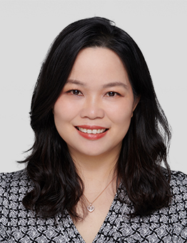
PRACTICE AREAS
MS. CAI’S PRACTICE FOCUSES ON M&A AND VENTURE CAPITAL INVESTMENTS, FOREIGN DIRECT INVESTMENT AND OVERSEAS CAPITAL MARKETS.

REPRESENTATIVE MATTERS AND CASES

- Represented Alibaba Group, Ant Financial and Ali Health in their strategic investments in, acquisitions of and cooperation with various enterprises in different industries such as TMT, finance, software development, healthcare, agriculture, sports and retail
- Represented 4paradigm, an AI unicorn enterprise, in its C+ round financing from various foreign and domestic investors
- Represented Mindray Biotechnology in its pre-IPO financing from more than 10 strategic and financial investors
- Represented Overseas Chinese Town Capital as a strategic investor in participating in the equity reform program of China SDIC Gaoxin Industrial Investment Co., Ltd.； with a total investment of RMB 5.467 billion, the program was the second largest capital increase project listed and completed through China Beijing Equity Exchange in 2019, and the largest investment in the state-owned enterprise reform “Double Hundred Action” in 2019
- Represented China Music Corporation in its merger with QQ Music — creating the largest online music platform in China
- Represented Boyu Capital and 58.com Inc. in their equity investment in Vanke Property Development Limited, a wholly owned property services unit of Vanke Group
- Represented a prestigious US fund in its disposal of the controlling stake in a PRC portfolio company through a bidding process
- Represented TPG in its sale of HCP to Baring Capital
- Represented Dongda Group in the sale of 100% equity interests in Dalian Dongda Water Treatment Co., Ltd. to China Everbright Water Limited
- Represented Asia Belt and Road Expressway Company Limited, a company ultimately held by CVC Asia Fund IV, in subscribing for 166,666,667 shares allotted and issued by RKE International Holdings Limited, an indirect wholly-owned subsidiary of Road King Infrastructure Limited (SEHK:1098)
- Represented several private equity funds in their acquisitions of and investments in various universities and K12 education groups
- Represented a private equity fund in its minority investment in an individual credit reference operator and in its acquisition of the operator the following year
- Advised various clients on the restructuring and setting up of VIE structures in different industries such as TMT, education, music and entertainment
- Advised multinational corporations on their strategic investment transactions, restructuring, foreign direct investment and other corporate matters such as establishment of foreign invested companies, employment matters, and sales and distribution
Education
- Northwestern University School of Law, LL.M
- Northwestern University Kellogg School of Management, Business Administration Certificate
- Peking University School of Law, LL.B
Professional Qualification
- Admitted to practice in the PRC
- Admitted to practice in New York
Professional Background
- Ms. Cai joined Fangda in 2005.

