SHUWEN HU  Counsel·Shanghai  +86 21 6263 5921  shuwen.hu@fangdalaw.com | 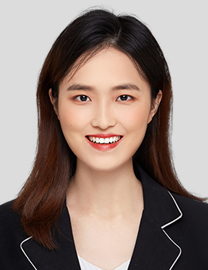
PRACTICE AREAS
MS. HU SPECIALIZES IN CAPITAL MARKETS, M&A, PRIVATE EQUITY AND GENERAL CORPORATE.

REPRESENTATIVE MATTERS AND CASES

- Represented Shanghai Fudan Zhangjiang Bio-Pharmaceutical in its A-share IPO on the STAR Market
- Represented Ant Group in its A-share and H-share dual listing
- Represented Focusight (Jiangsu) Technology in its A-share IPO on the STAR Market
- Acted as underwriter’s counsel in Shanghai New Centurion Network Information Technology’s A-share IPO
- Acted as underwriter’s counsel in Hangzhou Raycloud Technology’s A-share IPO on the STAR Market
- Represented China Shipbuilding Industry Group Power in its major asset restructuring
- Represented China United Travel in its major asset restructuring
- Represented Shanghai SynTheAll Pharmaceutical in its major asset restructuring
- Acted as the independent financial advisor’s counsel in the major asset restructuring of Sinopharm National Medicine
- Acted as the investor’s counsel in the major asset restructuring of Longshine Technology Group
- Represented Guangdong Ganhua Science & Industry Co. in its acquisition of a defense industry company
- Represented Black Peony (Group) in its acquisition of an infrastructure company that builds roads and bridges
- Represented Shanghai Kinlita Chemical in the transfer of its controlling right
- Represented Shenyang Blue Silver Industry Automatic Equipment and its controlling shareholder in their domestic financing
- Represented Shanghai Junshi Biosciences in its domestic financing
- Represented Fu Jian Anjoy Foods in the issuance of convertible bonds
- Represented Black Peony (Group) in its domestic financing
- Represented Zhejiang Cainiao Supply Chain Management in its investment in YTO Express Group’s convertible bonds
- Represented Alibaba in its investment in Beijing Timeloit Technology
- Represented Boyu Capital in its investment in Yimi Dida Supply Chain Group
- Represented Shanghai Fudan Zhangjiang Bio-Pharmaceutical in its investment in Shanghai WD Pharmaceutical Technology
- Represented Puyi (Shanghai) Bio-Tech in its Series B financing
- Represented Shanghai Fudan Zhangjiang Bio-Pharmaceutical in it’s a-share equity inventive plan and repurchase of H shares
Education
- Shanghai University, School of Law, LL.B.
- Fudan University, School of Law, LL.M.
Professional Qualification
- Admitted to practice in the PRC
Professional Background
- Ms. Hu joined the Shanghai office of Fangda Partners in 2018.

